GLOBAL MINING EGYPT 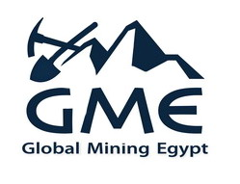
We are global mining company, which is Egyptian company based in Cairo.
We are mining, exporter, importer, agent, public procurement company.-
-We have our supplier for raw materials like silica sand, feldspar, calcium carbonate, dolomite, kaolin, quartz, gypsum, quick lime, which are used in several industries like Sanitaryware , ceramic , porcelain tiles,, glass, Frits ,glazes ,Paints, pharmacogical ,Plastic , papers
Cosmetics, petroleum, agriculture, Steel, cement, Cleaners.
-Our main goals to reach our customers desires and market demands.

2 El Eshreen st , Giza, Egypt Tel. Fax :002 023724877
T.ID : 401-605-094 File No : 5 – 2472 – 15 – 192 C.R: 219913
Mob: 002 01005673899 - 002 01275762897 - 002 01143939899
www. globalminingegypt.com E-MAIL: mali@globalminingegypt.com

